Experiment 16: HIGH LEVEL PROGRAMMING EXTENSIONS - PROCEDURES
Aim:
To implement procedures using program in MySQL.
PROCEDURES:
A procedure is a subprogram that performs a specific action.
Creating a procedure
We use the CREATE PROCEDURE statement to create a new stored procedure. We specify the name of stored procedure after the CREATE PROCEDURE statement. The DELIMITER command is used to change thestandard delimiter of MySQLcommands (i.e. ;). As the statements within the routines (functions, stored procedures or triggers) end with a semi-colon (;), to treat them as a compound statement we use
DELIMITER.
Calling stored procedures(Executing a procedure)
In order to call a stored procedure, you use the following SQL command:
CALLstored_procedure_name();
Problem 1:
Create a simple procedure to get all the records from the table ‘student_info’.
Problem 2:
Create a stored procedure GetCustomerLevel() that accepts two parameters customer number and customer level.
• First, it gets the credit limit from the customers table.
• Then, based on the credit limit, it determines the customer level: PLATINUM, GOLD, and SILVER.
• The parameter p_customerlevel stores the level of the customer and is used by the calling program.

Program-1:
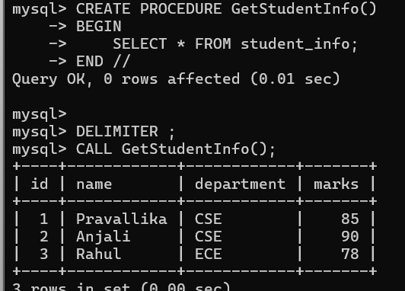
Program-2:
